**Experiment Title 3.1**

**Student Name: Sahul Kumar Parida UID: 20BCS4919**

**Branch: CSE Section/Group: WM-904/B**

**Semester: 5th**

**Subject Name: Project Based Learning using Java**

**Subject Code: 20CSP-321**

**1. Aim/Overview of the practical:**

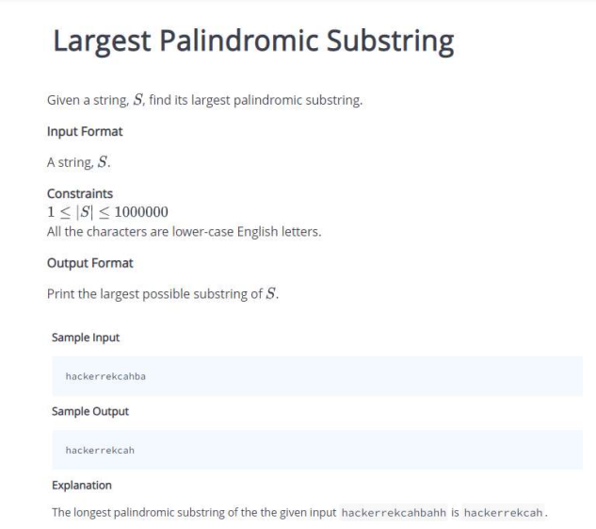

**2. Software/Hardware Requirements:**

# Windows

# BlueJ (Java IDE)

# JRE (Java Runtime Environment)

**3. Steps for experiment/practical/Code:**

import java.util.*;

class Exp3_1

{

static String longestPalin(String S)

{

int i=0,high=0,low=0,max_len=1,cur_len=0,n=S.length();

String palin= "";

if(n<2)

{

return S;

}

for(i=0;i<n;i++)

{

high = i+1;

low = i-1;

while(low>=0 && S.charAt(i)==S.charAt(low))

{

low-=1;

}

while(high<n && S.charAt(i)==S.charAt(high))

{

high+=1;

}

while(low>=0 && high<n && S.charAt(high) ==S.charAt(low))

{

low-=1;

high+=1;

}

cur_len = high-low-1;

if(cur_len>max_len)

{

max_len = cur_len;

palin = S.substring(low+1,high);

}

}

if(max_len==1)

{

return S.substring(0,1);

}

return palin;

}

public static void main()

{

System.out.println("20BCS4919");

System.out.println("Sahul");

Scanner sc = new Scanner(System.in);

String s = sc.next();

String res = longestPalin(s);

System.out.println(res);

}

}

**4. Result/Output/Writing Summary:**

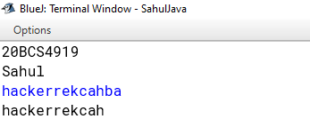

**Learning outcomes (What I have learnt):**

**1.String**

**2. Substrings**

**3. Methods and Functions**

**4. Call by value**